

**Computer architecture**

**LAB # 08**

**Submitted to:**

**Sir shoib**

**Submitted by:**

**Rabia Batool**

**2022-BSE-064**

**Exercise 9.1**

Write a program that input a character from user is in lowercase, the program will

convert it to uppercase and will display it on console after conversion.

Hint: - The ASCII codes for lowercase letters (a-z) are 97-122. In order to convert a

lowercase letter to uppercase letter, just subtract 32 from its ASCII code.

**Code:**

org 100h

.data

inMsg db "Enter a character: $"

outMsg db "Uppercase character: $"

newline db 0dh, 0ah, '$'

.code

main proc

; Display input message

mov ah, 09h

mov dx, offset inMsg

INT 21h

; Get input from keyboard

mov ah, 01h

INT 21h

mov bl, al ; Store the input character in bl

; Convert to uppercase by subtracting 32 from ASCII code

sub bl, 32

; Move cursor to new line

mov ax, @data

mov ds, ax

mov dx, offset newline

mov ah, 9

INT 21H

; Display output message

mov ah, 09h

mov dx, offset outMsg

INT 21h

; Display the converted character

mov dl, bl

mov ah, 02h

INT 21h

; Exit program

mov ax, 4C00h

INT 21h

main endp

end main

**Output:**

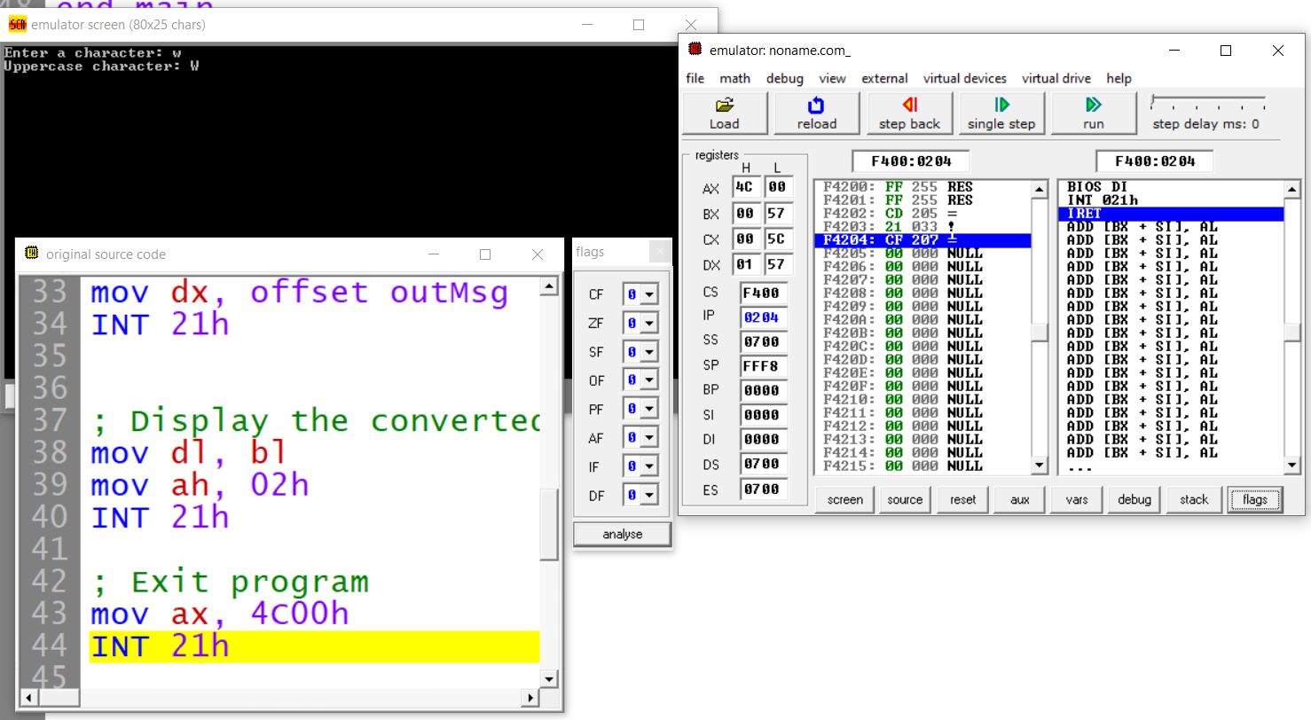

**Exercise 9.2**

Write a program that input a character from user. The program will display it ten times

on screen in newline.

**Code:**

;To read a character from keyboard

org 100h

.data

inMsg db "Enter a character: ",'$'

newline db 0dh,0ah,'$'

.code

main proc

;To display input message

mov ax, @data

mov ds, ax

mov dx, offset inMsg

mov ah, 9

INT 21H

;Get input from keyboard

mov ah, 1h

INT 21H

mov bl, al

;Move cursor to new line

mov ax, @data

mov ds, ax

mov dx, offset newline

mov ah, 9

INT 21H

mov cx, 10 ; Counter for displaying the character ten times

agn:

mov dl, bl ; Display the character

mov ah, 2h

INT 21H

mov dx, 0Dh ; Move to a new line

INT 21h

mov dx, 0Ah ; Move to a new line

INT 21h

LOOP AGN

mov ax, 4c00h ; Exit program

INT 21h

main endp

end main

**OUTPUT:**

